**Axminster Allotment & Leisure Gardeners Association**

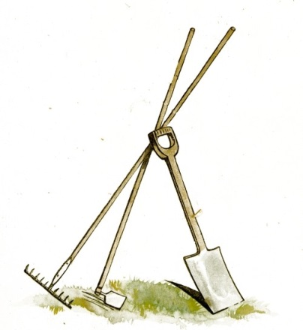

Affiliated to the National Society of Allotment and Leisure Gardeners

**Member Contact Details and Data Consent Form**

PLEASE CIRCLE Allotment Site: Woodbury Park - North Street - Millwey - and add plot number, or Private Garden (Leisure Gardener)

|  |  |
| --- | --- |
| NAME: | |
| ADDRESS: | |
|  | POSTCODE: |
| TELEPHONE NUMBER(S): | |
| EMAIL: | |

**Data Consent**

By signing this form, you ae confirming that you consent to the Axminster Allotment and Leisure Gardeners Association (AALGA) holding and processing your personal data for the following purposes:

* To include my details on the database list of members provided to the National Society of Allotment and Leisure Gardeners, and for use by appointed Committee Officers to facilitate the running of the Association
* To keep me informed about news, events and activities relevant to AALGA through occasional email or postal communications from the appointed Committee Officers.

I consent to the use of this information as indicated above until such time as I submit a revised form, or contact you about changes I wish to be made to this information or write to withdraw my consent.

|  |  |
| --- | --- |
| Signed:  (type name if completing electronically) | Date: |

Joining the Association gives you the following benefits:

* subscription to the National Society of Allotment and Leisure Gardeners. You can purchase **seeds** at a **40% discount** on retail prices.
* annual public liability insurance cover against claims from third parties for accidental injury on your plot
* Discount on plants at Groves Nursery, Bridport and Little Groves Nursery **(10%)** on presentation of your membership card. Terms apply.

Membership subscription £6 for the year 2024/25 payable by bank transfer, cheque or cash.

The Bank details are Axminster Allotment and Leisure Gardeners Association, Lloyds Bank, Sort Code 309037 Account number 01517937. Please give your Initials, Allotment Site: WP, MR, or NS and plot number, or LG.

Please return this form to the Membership Secretary – Louise Taylor, Trotters, Pig Lane, Axminster

EX13 5GH or email it to [membershipaxallots@gmail.com](mailto:membershipaxallots@gmail.com)